S3 bucket task

1.Create an S3 bucket and upload some objects to S3.

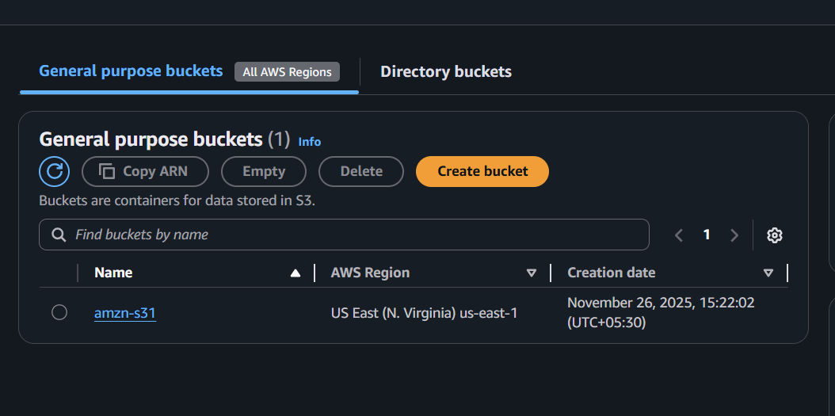

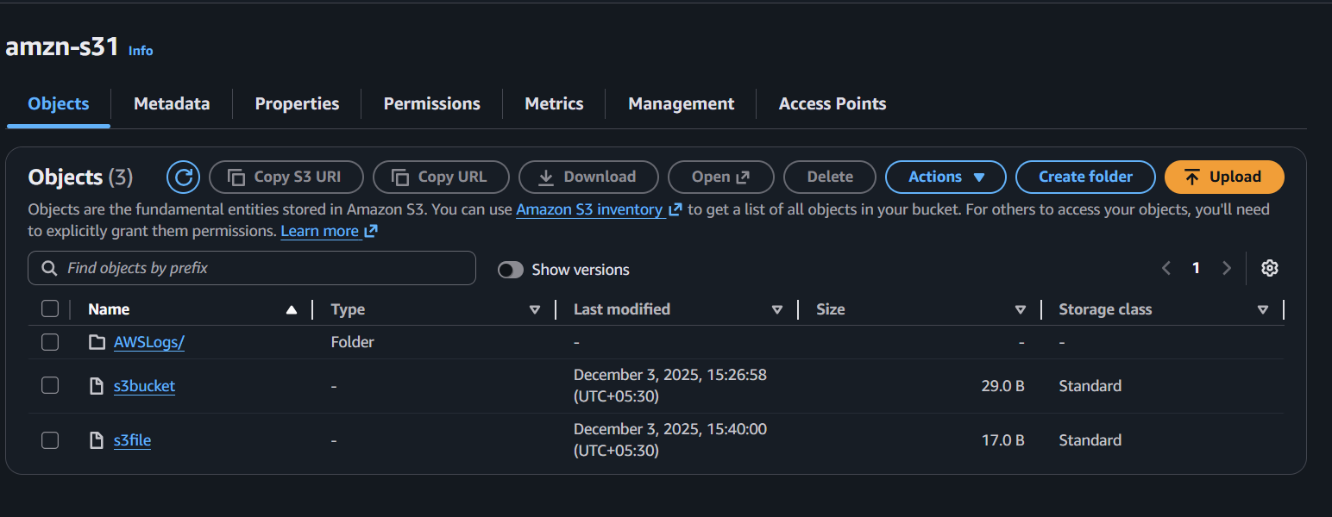

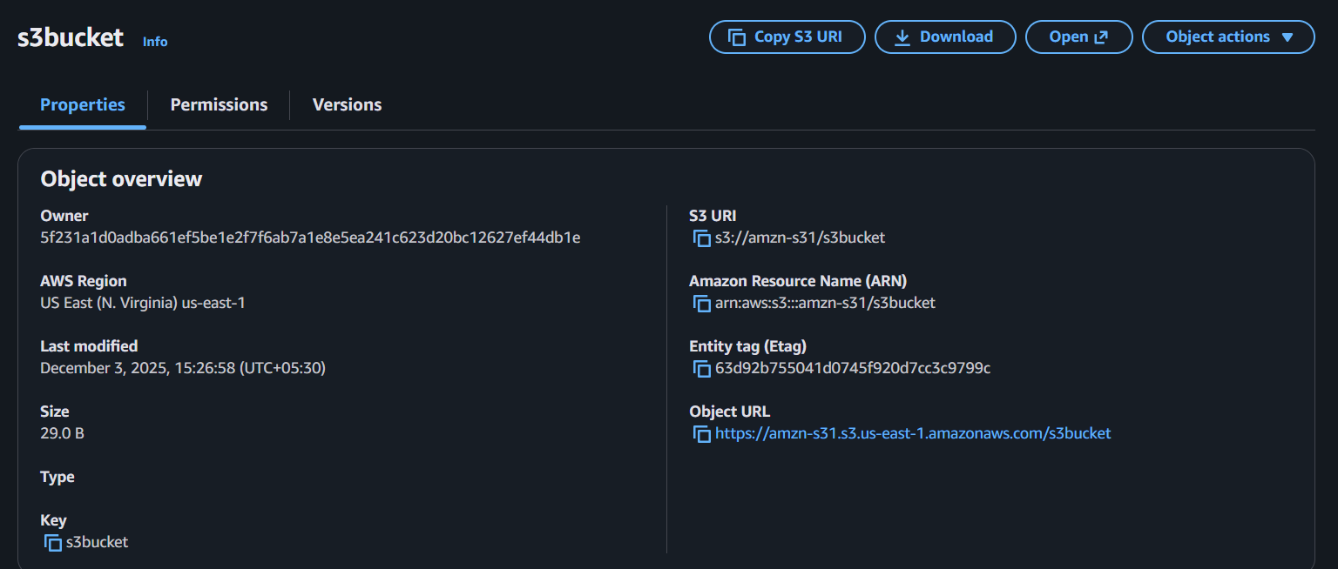

- Deploy a static website in the S3 bucket.

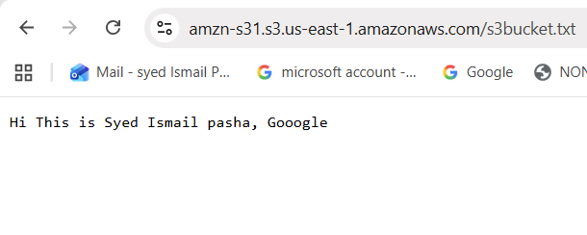
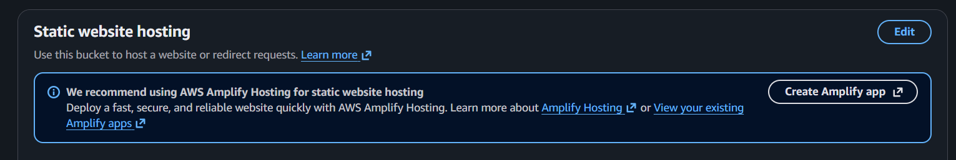

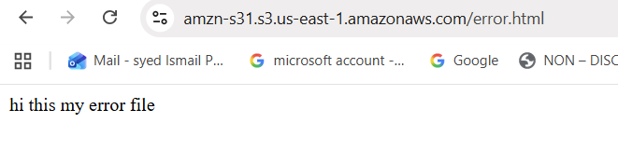
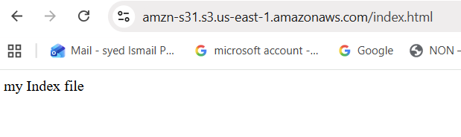

- Enable cross-region replication on S3 buckets.

Hyd0123 region data:
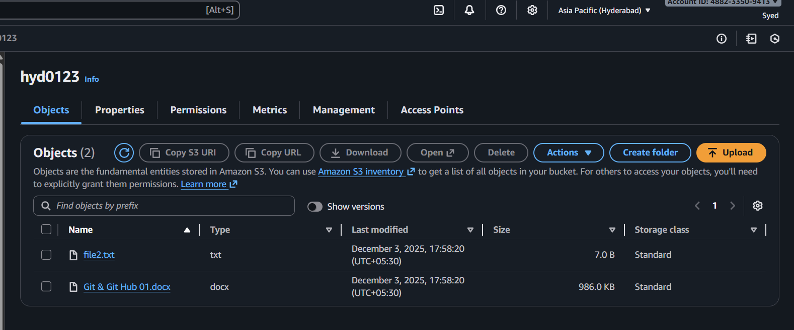

Data transferred successfully
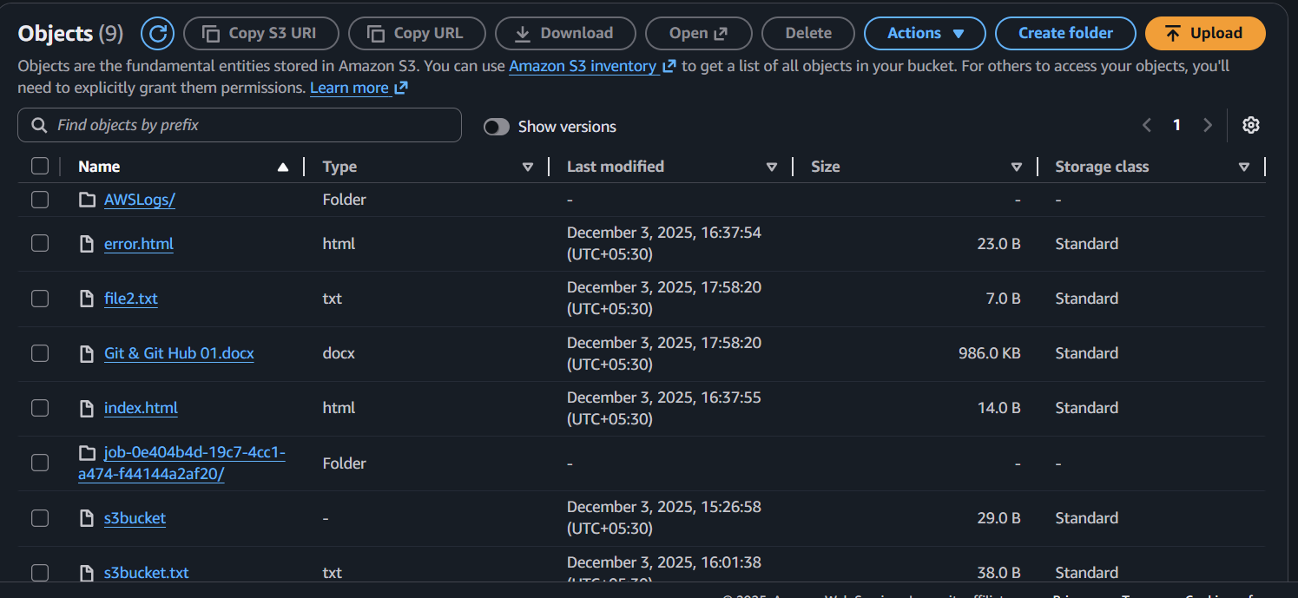

- Configure a bucket policy so only the Admin user can see the objects of the S3 bucket.

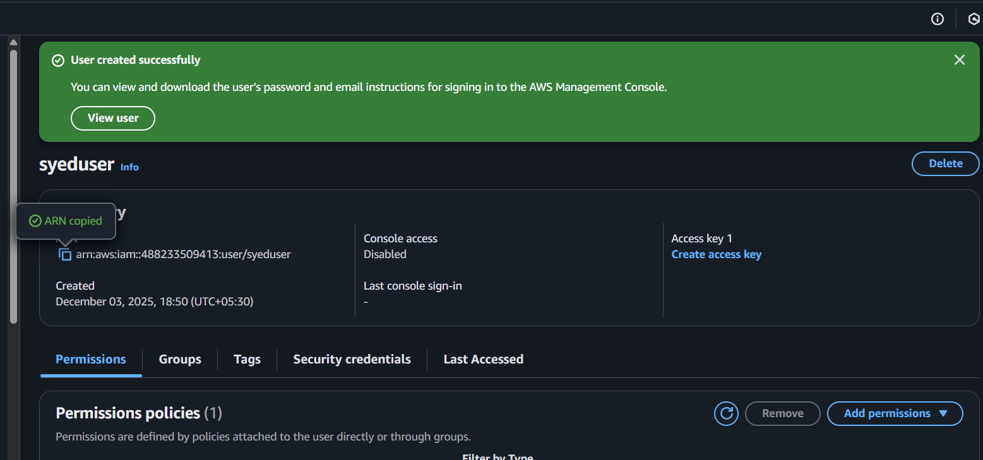

- Set up lifecycle policies to automatically transition or delete objects based on specific criteria
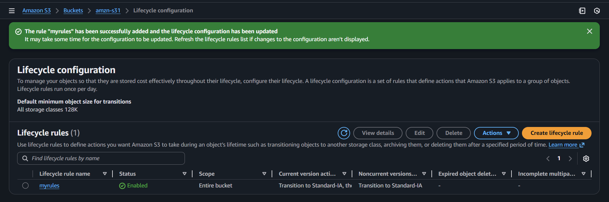
- Push some objects to S3 using the AWS CLI.

First we have to configure the AWS
and upload the file
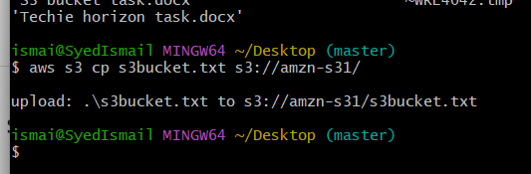
Time 7:28pm date dec/03/2025

- Write a Bash script to create an S3 bucket.
Run the script
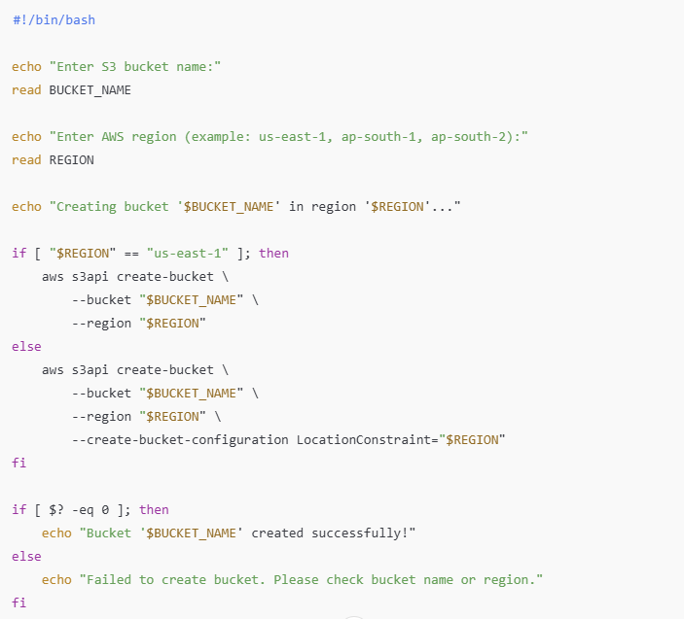
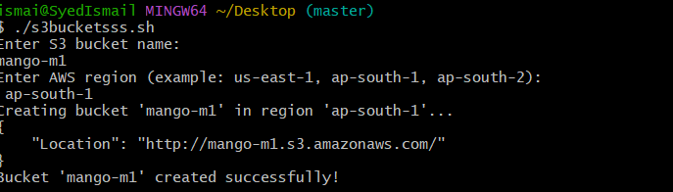

- Upload a 1 GB file to S3 using the CLI.
Step:
dd if=/dev/zero of=bigfile.bin bs=1M count=1024
aws s3 cp bigfile.bin s3://hyd0123/
aws s3 ls s3://hyd0123/
